MINUTES OF PWCFP MEETING
VIA CONFERENCE CALL
October 28, 2017

Call to Order / Lighting the Christ Candle: Moderator Karen Hamilton.

Devotional: Women of the Reformation by Rev. Jeannie Simpson, presented by Karen Hamilton.

PW Purpose: Forgiven and freed by God in Jesus Christ, and empowered by the Holy Spirit, we commit ourselves: To nurture our faith through prayer and Bible study; to support the mission of the Church worldwide; to work for justice and peace; and to build an inclusive, caring community of women that strengthens the Presbyterian Church (U.S.A.) and witnesses to the promise of God’s kingdom.

Roll Call: Attending: Karen Hamilton, Barbara Joyce, Abbie VanDenBerg, Jean Evans, Sharon Williams, Jennifer Jones, Roselyn Calvert, Jill Bolander Cohen, Carol Potter, Ruth Ann Stearns, Beth Timmons and Debbie Horn. Unable to attend: Kay Kennedy, Olga Mercado, Barbara Miller, Sandy Weil, and Brenda Tompkins.

Secretary’s Minutes: The May minutes have been approved and posted on www.pwcfp.com website.

Treasurer’s Report: Jennifer Jonas presented the Q3 report, attached as Exhibit A-1. The deficit, brought about by the Bible Study was due, in part, to Tampa Bay withdrawing financial support. A Bible Study Overview, provided by Jennifer Jonas (Exhibit A-2), provided specific numbers for the study. Jennifer reported that former OIKO funds approximating $20,000 are earning very little interest at Sun Trust Bank and recommended moving some of those funds into a CD for more growth. $10,000 of those funds is designated for PW VOCATIONAL SCHOLARSHIPS. Jennifer was thanked for her hard work and asked to investigate a new, easier-to-understand, format for presenting the budget numbers. Jean also requested clarification of the funds received for 2¢ a Meal. According to the Bible Study overview, donations of $101.91 were received and paid out.

Auditing: Because the By-laws of PW require that the financial records be audited routinely, steps will be put into place to find an independent auditor to review the books . A motion that the books be audited following the end of the fourth quarter, to take place after the Annual Gathering, was presented by Abbie VanDenBerg, seconded by Carol Potter, and unanimously adopted. Abbie, Sharon and Karen will designate an independent auditor. Karen took the opportunity to discuss the income needed from pledges. For the past several years, PW has been making up the deficit between the pledges and the amount sent to the Synod. If pledges do not increase, a drop in the amount sent will need to be considered. Jennifer Jonas will contact the treasurers of the districts to encourage pledges

Bible Study: Karen reported that numerous women commented on how well the Bible Study went, from the inception through registration and programming. Jennifer Jonas and Abbie VanDenBerg were specifically acknowledged for their hard work and Melissa Bane Sevier expressed her appreciation to the entire PWCFP CT for our hospitality and excellent program preparation.

Moderator’s Report: Karen Hamilton.

On Saturday August 12, 2017, our annual Bible Study Event sponsored by Presbyterian Women in Central Florida Presbytery was held at the Maitland Presbyterian Church. The event opened at 9:00 a.m. with a buffet breakfast followed by a worship/communion service at 10:00 featuring Rev. Melissa Bane Sevier, the author of our study book, Cloud of Witnesses, The Community of Christ in Hebrews. Melissa led two study sessions that offered a complete overview of each of the nine lessons on the various themes in the book of Hebrews. Between study sessions, attendees were served a luncheon, family-style. Lunch consisted of potato, tuna, chicken and tossed salads with croissants and numerous small dessert bites provided by PWCFP Coordinating Team members. The ladies were especially appreciative of the study suggestions booklet of materials provided to each. It’s a great idea for helping those leading the Bible study each month. Please come and join us as we work our way through the book of Hebrews and learn more about our community of believers.

Rev. Melissa Bane Sevier provided individual/group questions for further discussion:
- How do we develop and encourage intimacy with God in our communities of faith?
- Does it make a difference when we hear and process our faith and our ideas in community? How so? Or not?
- What kind of messages do you think God has sent you when you welcomed a stranger or were the recipient of hospitality?
- How do we balance our need for community with our need for alone time?
- Name something from the tradition that is one of the stones in the wall of your faith.
- What can a 21st century congregation in the United States of America learn from South African churches under apartheid several decades ago (Belhar Confession)?
- Describe a time when a community you’re a part of witnessed suffering, and a time when it helped alleviate suffering.
- In what ways can your household of faith be more inclusive?
- Briefly tell the story of someone who has influenced your life.

As Rev. Melissa Bane Sevier feels music is so important to share community in each of the Hebrews lessons, PWCFP has developed the following guide to aid our PW sisters.

2017-2018 Horizons Bible Study Music
Cloud of Witnesses: The Community of Christ in Hebrews by Melisa Bane Sevier

Lesson | GtG | PH | Title of Song
1 | 394 | 417 | Christ is Made the Sure Foundation
 | 262 |  | Since Our Great High Priest, Christ Jesus
 | 267 | 150 | Come Christians, Join to Sing
2 | 49 | 488 | The God of Abraham Praise
 |  | 296 | Walk On, O People of God
 | 59 |  | The Steadfast Love of the Lord
3 | 459 | 327 | O Word of God Incarnate
4 | 113 | 23 | Angels We Have Heard On High
 | 123 | 38 | It Came Upon a Midnight Clear
5 | 730 | 364 | I Sing a Song of the Saints of God
 | 331 |  | God of the Ages, Whose Almighty Hand
6 | 177 |  | I Will Come to You
7 | 824 | 527 | There Is a Place of Quiet Rest (Near to the Heart of God)
 | 393 |  | O Day of Rest and Gladness
8 | 322 |  | We Are One in Christ Jesus
 | 754 | 358 | Help Us Accept Each Other
9 | 326 | 526 | For All the Saints
 | 543 |  | God Be the Love to Search and Keep Me (O Christ Surround Me)

Presbyterian Women of Central Florida Presbytery Coordinating Team wishes to thank all who contributed to our most successful Bible Study Event:

Honored guests from Presbyterian Women, Synod of South Atlantic--Erma Jones, Moderator; Isabel DuBose, Secretary/Historian; former Moderator Mary Bell Streetman
Tampa Bay PW--Moderators Ellen Stoup, Sue McClue, Robin Powell
Central Florida PW--Moderators Mary Bell Streetman, Connie Herr, Rose Gorman, Karen Hamilton

Special thanks go to Maitland Presbyterian Church: Rev. Megan Collins, Mrs. Labert Altemose, Robert Jones (Sexton), Barry VanDenBerg (AV Tech), Margaret Patten (Music), Dustin Dearing (Youth Group), Debbie Horn (PW Moderator), Abbie VanDenBerg (Communications Specialist), Jennifer Jonas (Registrar), and Circle Moderators Linda Adkins, Helen Lamont, Brenda Coppinger, Abbie VanDenBerg, Barb Joyce, Jean Evans, Kathy McLain, Jill Bolander Cohen, Marcia Brown, Betty Kimbrel, Soni Dorr, and Carolyn Goodman.

PWCFP Coordinating Team members participating in the planning and worship service were Abbie VanDenBerg, Debbie Horn, Carol Potter, Jennifer Jonas, Jean Evans, Sandy Weil, Beth Timmons, Sharon Hudson Williams, and Karen Hamilton.

Participating churches in Central Florida and Tampa Bay Presbyteries were Maitland, First DeLand, Wekiva, St. Mark’s, North Lake, First Lakeland, Park Lake, Northwood, First Vero Beach, First Auburndale, South Lake, Trinity, Glenwood, First Titusville, Peace Memorial, Washington Shores, Tuskawilla, St. Andrews, Pineda, Oakland, First Brooksville, Rockledge, Cocoa, First Leesberg, Church of the Highlands, First Winter Haven, First Sebastian, Good Samaritan, Hope, John Knox, Palm Harbor and Palma Ceia. Total participants numbered 190!

Additional Bible Study helps can be found beginning with the July/August issue of Horizons magazine or on the PW website www.presbyterianwomen.org. Now is also the time to order the 2017 Thank Offering materials “For the Healing of the Nations.” Please remember to send your 2018 Mission Pledge Form to Jennifer Jonas, PWCFP Treasurer, by November 2017.

Vice Moderator’s Report: Sharon Williams.

- Attended leadership meeting on August 11th with Synod people, ladies from Tampa Bay, our team, and Melissa Bane Sevier.
- Attended Bible Study Event and participated in worship service on August 12th
- Met with PWCFP Annual Gathering planning subcommittee Abbie VanDenBerg and Olga Malve-Radi) to go over plans for January meeting.
Parliamentarian Report: Kay Kennedy. No report received.

Search: Rosellyn reported on her efforts to secure District 1 and 8 Coordinators. Secretary/Historian position was filled by Debbie Horn’s appointment in June to fill out the unexpired term. Rosellyn also coordinates the $.01/meal contributions. She provided the full list of coordinating team members and those to be installed at the 2018 Annual Gathering.

Communication: Abbie VanDenBerg.
- Developed Annual Bible Study Program booklet
- Made Registration Check in Forms
- Made Name Tags
- Set up for Bible Study Event
- Planned Leadership Dinner on Friday, Aug 11th with Synod people, Tampa People, PWCFP and Melissa Bane Sevier
- Ran around tending the Bible Study Event on Aug. 12th answering questions, solving problems and participating where and when required.
- Made sure people who needed to be paid got paid for event.
- Wrote thank you cards to all who volunteered from Maitland Pres or other churches (25+)

- Met with PWCFP Annual Gathering planning subcommittee on September 27th with Sharon Williams and Olga Malave-Radi where we finalized the cost, the theme, and discussed the options for the break-out sessions after lunch. Olga will report back on questions we had at next subcommittee meeting on Nov. 29th at 6:30 p.m.

- Attended Mission Tea at Oakland Presbyterian Church on Saturday, September 30th. The fashion show, tea and food were terrific. I think Oakland Pres has a great campus and would be a good spot for a PWCFP annual event.

- Attended the PW Thank Luncheon at Maitland Pres on October 8th, spoke about Thank Offering recipients, and had a nice visit with Karen Hamilton and Rita Reid.
On the website:
- Updated Forms, calendar, leadership page, home page.
- Sent materials to District 1 churches as needed.
Interpreters:

Cultural Diversity: Olga Mercado. No report.

Global Missions: Barbara Joyce.

- I attended and chaired the Global Mission Meeting for the Central Florida Presbytery on October 4th @ Maitland Presbyterian Church.
- I attended the Cuba Leadership Team meeting in September. There are 27 members in the Central Florida Presbytery going on the Cuba trip in February 2018.
- I forwarded on Mission opportunities to the churches in our Presbytery and reminded them of Grants available through CFP. The grant application has been updated and has been distributed to the churches.
- I sent mission information to the Mission Committee Chair persons at all the CFP churches on supporting our missionaries worldwide.

Justice and Peace: Jill Bolander Cohen will be submitting a report but verbally reported that Peace USA will take place on September 7 and 8, 2018 at Maitland Presbyterian Church. Megan Collins will preach and there will be several key note speakers, including Jimmy Hopkins. Churches wishing to have those speakers present for Sunday Worship on September 9th should contact Jill for additional information. This will be a national PCUSA Event entitled Compassion, Peace & Justice.

On May 5, 2018, a women’s empowerment event is being scheduled at the Carter Center in Atlanta, Georgia. Speakers are being lined up and the program will include Human Trafficking, Domestic Violence and Date Rape at the College level.

Reporting on the Life Boat Project, Jill reported that there are 12-13 survivors being cared for. One survivor will be returning to New York through the Freedom Network. She also reported receiving a three-year Federal grant for training and housing which could provide up to $1,000,000 in assistance. She also asked for donations of gift cards for the survivors who need clothing and care products.

Pres. Home/Schools: Barbara Miller was not available and there was no report. Carol Potter did remind the council that scholarships are available to PCUSA students only. Karen Hamilton that North Lake had Holly Reimer eligible for a scholarship and the application is downloadable from our website.

District Coordinators:

District One: Vacant. .

District Two: Sandy Weil. No report.

District Three: Carol Potter.

- Lake Square PC is now named GRACEWAY PC. I am forwarding materials to the church secretary who gives them to the Session member in charge of small groups. I also made a trip over this summer to take a packet of PW materials, copies of what I received at the Triennial meeting to help in developing a program there. Haven't heard how they are doing, but will try again to make contact.
- I have talked to and visited with Rev. Susan Takis of Wildwood PC. I took her a copy of this year's Horizon Bible Study and a collection of PW materials to assist her in establishing a PW at her church. She has always been active with PW and is desirous to have a group at Wildwood. She has started 2 circles at the church and will lead the Bible study there.
- I have had a phone conversation with Maralyn Barry, moderator of So. Lake PC, and forward her materials to help with financial handling concerns for her PW group. She thinks those materials and our conversation has cleared her/their thinking on the means of handling their PW funds.
- The North Lake PW Moderator asked me to forward minutes from our CT meetings to CFPWCT. There has been no precedent for that, but I did send minutes of the last meeting and am interesting in what CFPWCT's thinking is on that. Is that something desirable, or just extra material we don't need or wish???? I think, perhaps, she may think it may give others ideas of things to try. What does our CT think?
- The Leesburg Church tried to get interest in forming a PW, but despite their effort, it didn't happen. They are still struggling some after their church split of several years ago.
- I have not been able to reach the other churches on my district list.
District Four: Ruth Ann Stearns.

- I have sent the promotional materials for the 2018 Gathering to each of the churches in District 4.
- Some investigation discovered 2 churches on the Presbytery PW Moderators directory which are no longer active or PCUSA (John Calvin, Orlando and St Paul's, Ocoee)
- The Celebration church - Community Presbyterian Church - responded for the very first time. Carolyn Garcia sent a thank you email. What a nice response.
- Annie Aker of Washington Shores Presbyterian Church is no longer able to participate. She has been replaced by Edith Brooks. Communication can be sent to the church for Edith.
- Email address change for Oakland Presbyterian Church's moderator, Kelly Parker - flparker@centurylink.net - replacing Earthlink.
- Oakland Presbyterian Church Presbyterian Women had a successful Annual Tea. At the last quarterly meeting, it was voted to pledge $150.00 to PW at PCUSA, $250.00 to SOSA, and $500 to PWCFP. The check will be in the mail at accompany the pledge. The Tea also raised $780.00 to our Christian Youth Musicians who acted as servers for the Tea. We are so grateful to their presence. A special thanks to our own Karen Hamilton and Abbie VanDenBerg for attending our event. Jean Homrighausen of Thornwall brought such an inspiring message that it was voted to ask Rebekah McConn of Thornwall's Building Families Outreach program to come to speak to us in January. We hope she will be available. We also are looking to help provide some of the items that can be used in that program. What an inspiration. We highly recommend it. Oakland PW have monthly Bible Studies and "Lunch Out" fellowship. We are encouraged bu the positive response to our PW Prayer Ministry - fashioned similar to the "prayer chain" idea. We have new requests weekly. But, some requests stay on our list more than a month, we pray for healing for our beloved Karen Hamilton.
District Five: Jean Evans. She further reported that Westminster Presbyterian has been dissolved.

- Attended Community Outreach meeting at Maitland Pres 8/1/17, 9/7/17.
- Attended Cuba Pastor Ludimilla dinner at Maitland Pres 9/7/17.
- Helped set up and attended Annual Bible Study 8/11 & 8/12/17.
- Attended PW Council meeting at Maitland Pres 8/27 & 9/24/17.
- Forwarded all correspondence from Karen to District Churches.

District Six: Brenda Tompkins.

- I have tried to contact all my Churches with no replies. I do have a name and e-mail for College Park Presbyterian.. She is very active and wants to be in the loop. Please Lord let me find more like Bonnie. To update your files and future correspondence: Bonnie Keller 407-277-3574, 407-405-6326, ebonniek@cfl.rr.com. St Johns Presbyterian was resolved and the property has been sold. I will continue to work on finding updated contacts.
Districts Seven and Eight: Beth Timmons.

- I’m still trying to contact all the District 7 and 8 churches. I was blessed to catch up with some at the BIRP Mission Conference in October. I sent copies of upcoming dates through pastors or church offices and some by mail. I have not received addresses or phone numbers for some of the churches. PWs at Cocoa, Rockledge, Riverside, 1st Titusville, St. Luke’s, Vero, Palmdale, Pineda, Good Shepherd and Sebastian are doing well. Merritt Island and Palm Bay do not have PWs at this time.

Old Business:

Bible Study August 12, 2017: The financial report, provided by Jonas, is attached.

Annual Gathering Committee Report: Abbie will provide a draft of the Registration Form. It will be held at El Redentor. Planning is underway. Cost will be $15. Breakfast and lunch will be similar to the last gathering. Fliers need to be distributed to churches as quickly as possible.

Positions to be filled: District Coordinators for 1 and 8 are needed. If they cannot be identified, the districts may have to be regrouped into six districts.

New Business:

Notes from SOSA CT MTG Columbia Seminary October 20-21, 2017

- Pledges to synod and church wide are down. Encourage all churches to submit 2018 Budget to Jennifer by end of November so she can develop our presbytery budget and send on monies for synod and church wide.
- In order to cut PW SYNOD BUDGET, the spring SOSA CT meeting will be by telecommunication. The October 2018 meeting will continue to be at Columbia Seminary in conjunction with Mission Haven and Columbia Friendship Circle.
- PW Church wide registration starts in January. Synod shirts will include coral cotton shirts as well as the turquoise shirts. The synod luncheon tickets will be $22 and I will be selling them until July 1, 2018. Big push for Church wide at PWCFP Annual Gathering! Scholarship monies of $375 will be supplemented by an additional $750 from Epworth gathering for a first time attendee. ( PWCFP CT members in good standing will receive $1,000 to attend Church wide August 2-5, 2018.)

- Reduction in mileage fees. Mission Haven $0.17/mile. SOSA CT $0.25/mile. It was decided that a drop in the reimbursement will discourage attendance at important meetings. It was decided, therefore, to maintain the mileage reimbursement at $.40 per mile.
Notes from Presbytery Meeting Vero Beach October 19, 2017

- CFP examined Candidate Jody Mask for ordination as a member of CFP to serve as Associate Pastor of Markham Woods Presbyterian Church. Olga Malave (El Redentor) ia graduate of San Francisco Theological Seminary, and Christina Greenawalt St. Andrews) a graduate of Reformed Theological Seminary are available for pulpit supply. Holly Reimer (NorthLake) is eligible for a PWCFP Scholarship.
- Rev. Laura Viau (First PC Apopka) will be 1 of 6 commissioners to the General Assembly in St. Louis, Missouri, June 16-23, 2018. Mary Bell Streetman will serve as CFP representative to Synod meetings 2018-2010.
The 69th Anniversary Columbia Friendship Circle Scholarship recipients for 2017-2018 were:

- Zak Fletcher, Mdiv/MAPT ‘18
- Paige Woody, Mdiv ‘19
- Sungwoo Sam Kim, Mdiv/MAPT ‘18
The April 26, 2018 Columbia Friendship Circle Meeting will be added to the 2018 Calendar.

Proposed 2019 Calendar of Events:

1/5/19 – 10:00 a.m. – CT at St. Mark’s Presbyterian Church.
1/26/19 – Annual Gathering, location to be determined.
03/10/19 – 10:00 a.m. – CT, location to be determined.
05/04/19 – 10:00 a.m. – CT at Maitland Presbyterian Church.
08/10/19 – Bible Study, location to be determined. Ruth Ann will discuss with Oakland.
10/5/19 – 10:00 a.m. – Conference Call CT
10/25-27/19 – Triennial Gathering, Epworth By the Sea.

Prayer Requests:

Kay Kennedy and her sister, Norma.
Dan Williams, for healing
Karen Hamilton, for future medical testing
Barry VanDenBerg, for strength and acceptance in the loss of sight in one eye.
Jennifer Jonas, for praise and prayer as she adopts her son, Dustin on November 22, 2019.

There being no further business to conduct, the meeting was adjourned at 11:41 with prayer by Karen Hamilton.
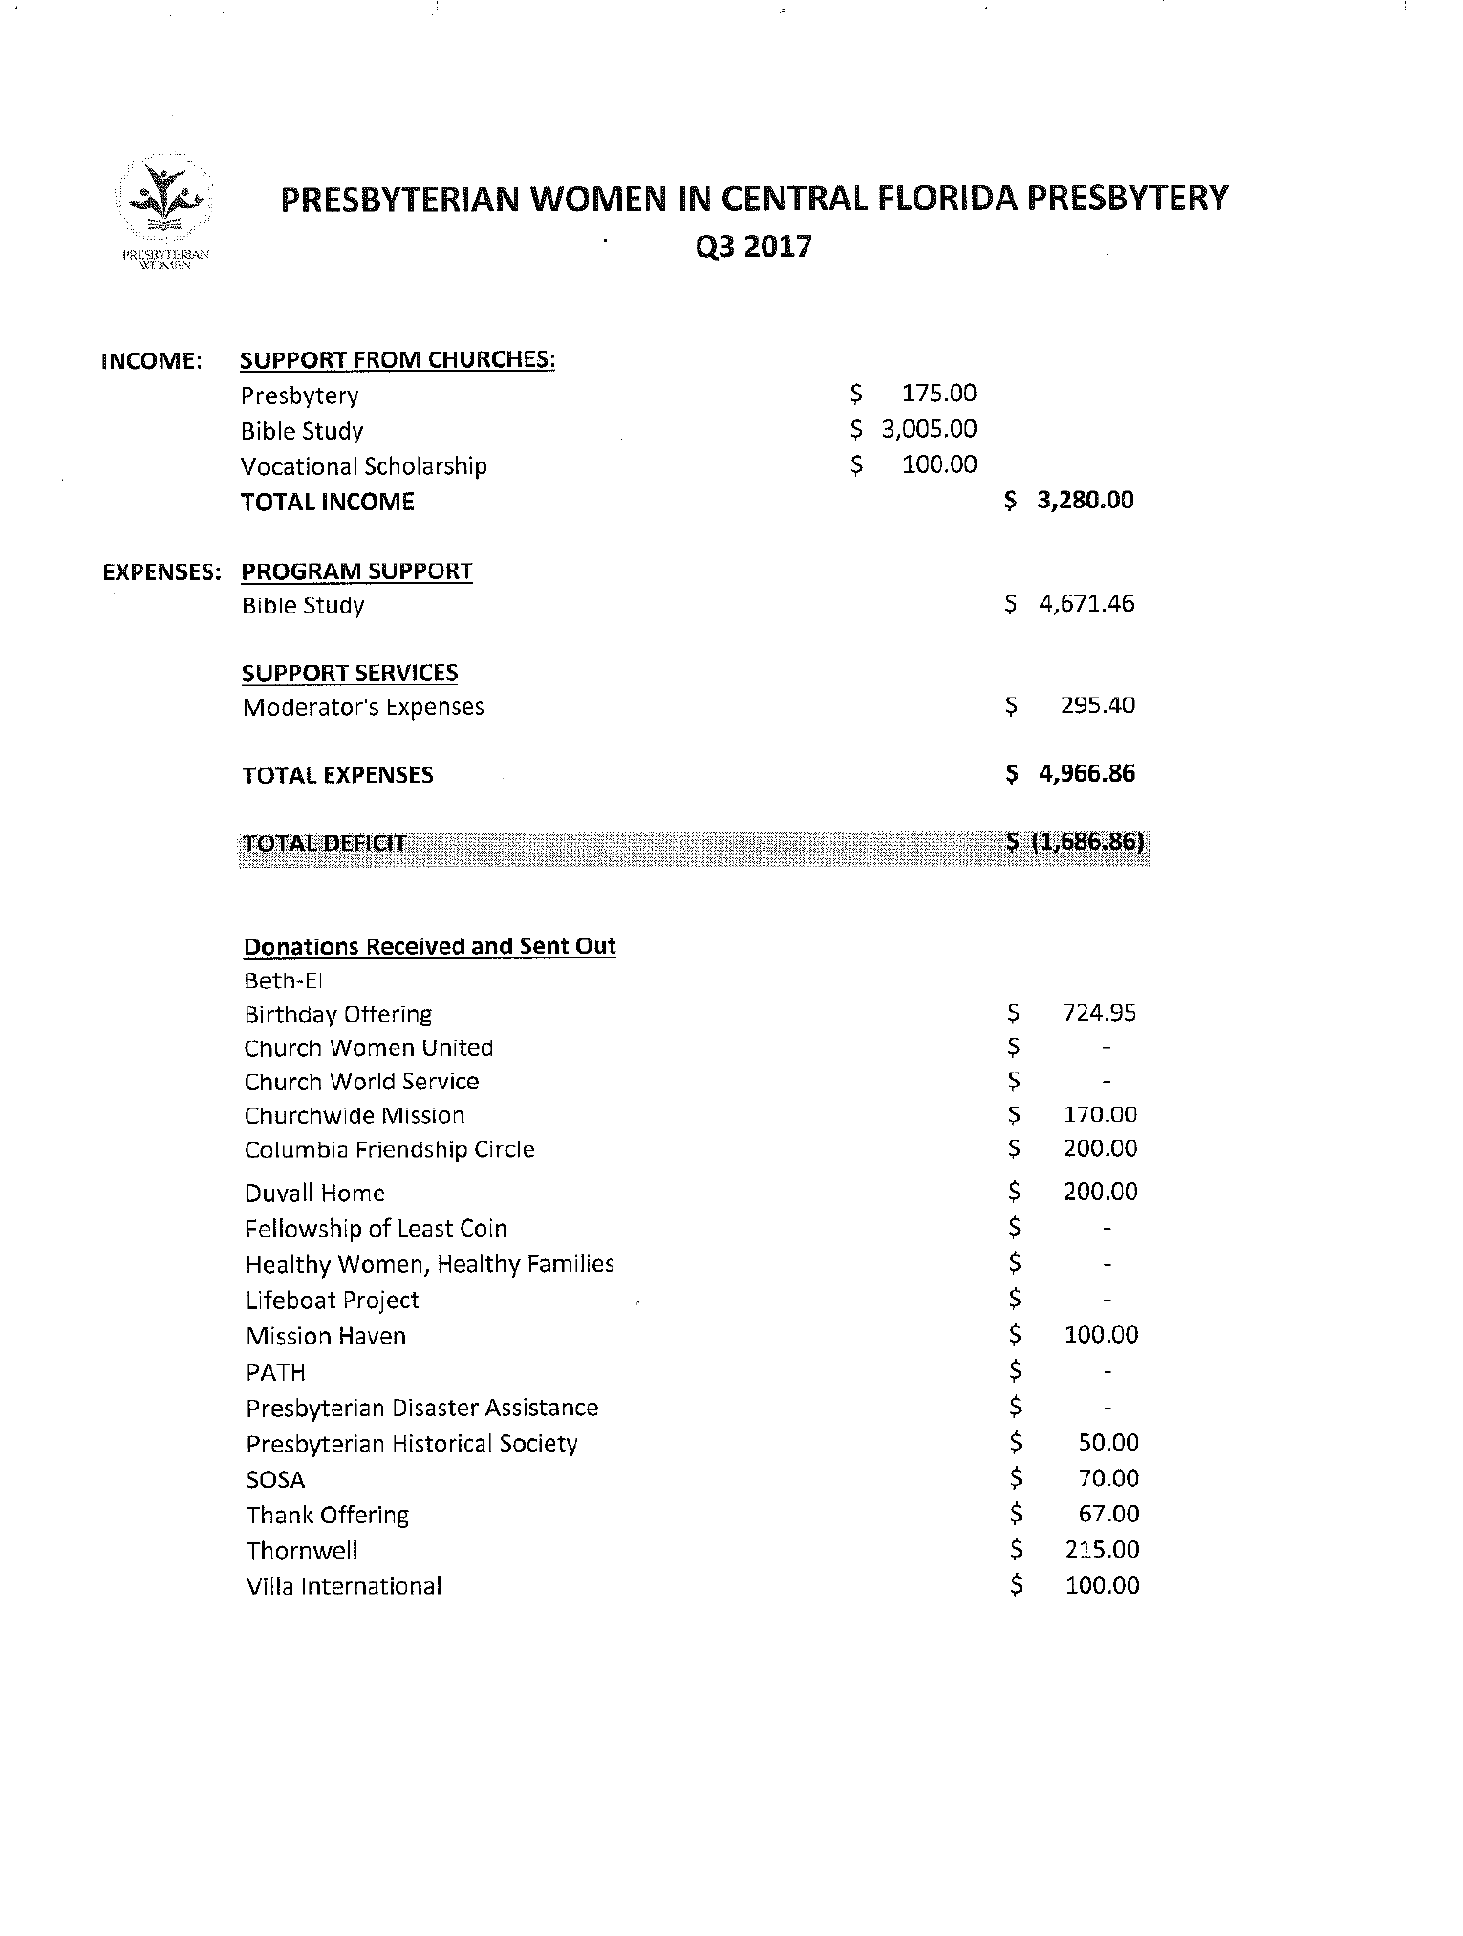
EXHIBIT A-1
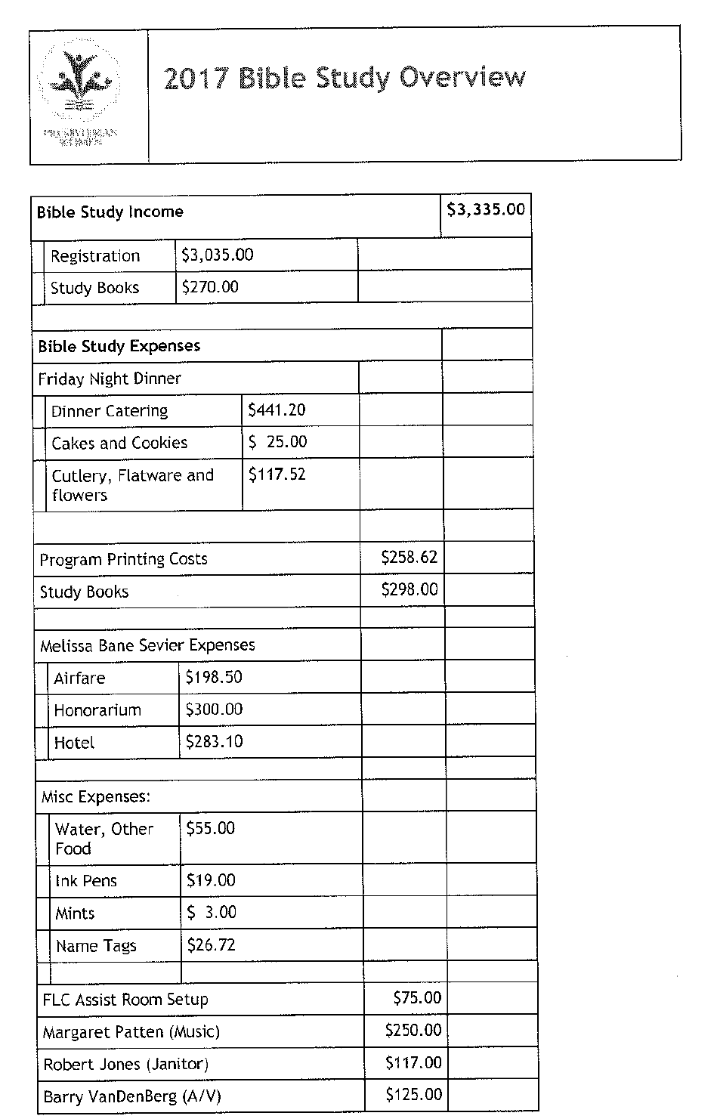

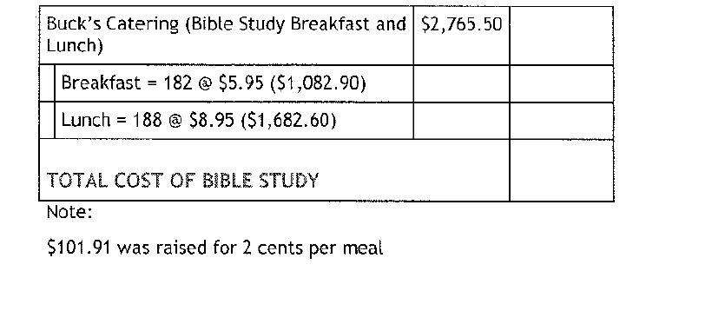

EXHIBIT A-2

